GULISTAN & TURGUT OZAL EDUCATIONAL INSTITUTIONS
INFORMATICS LESSON PLAN

DATE : DURATION: 40 minutes
GRADE LEVEL : 10th Class
SUBJECT : Decision statements - 1
OBJECTIVES : To learn how to use standard functions, Boolean Operations and Decision Statements
LESSON PLAN
Key words :
Warm-up :

Introduction and explanation of the lesson;
In our daily life, we often encounter many options and we have to select one. Our selections decide the way of our life. In every separation point we make our decision and go on our way. While programming, we usually need to decide the path of the program flow according to the parameters and conditions. Actually the ability of making decision is one of the key points of intelligent programming. Thanks to control structures (decision & repetition) we are able to evaluate the condition and select the flow path. We have 4 types of decision structures in C++:
- If
- If/Else
- Conditional Operator (?)
- Switch
The If/else statement chooses between two alternatives. This statement can be used without the else, as a simple if statement. Another decision statement, switch, creates branches for multiple alternative sections of code, depending on the value of a single variable. Finally, the conditional operator is used in specialized situations.
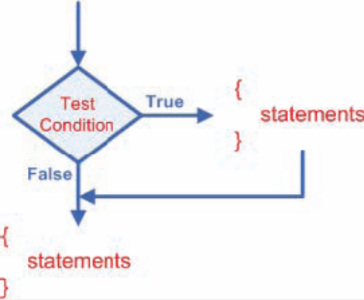
The if structure
The "if structure" is used to execute statement(s) only if the given condition is satisfied. The Computer evaluates the condition first, if it is true, statement is executed if not the statement is skipped and the program continues right after this conditional structure. This can be illustrated as:

The following code prints "passed" or "failed" depending on the average of the student by using two separate if structures.

if (average>=60){
cout<<"passed"; //if the average is greater than 60,
//print passed.
}
if (average<60){
cout<<"failed"; //if the average is less than
//60, print failed.
}

The first if structure checks whether the average is greater than 60, if so writes "passed" to the output. The second "if structure" checks whether the average is less than or equal to 60. If so, it writes "failed" to the output. If we have a single statement in a "if" then it can be written without braces; but if we have a compound statements to be executed we need to enclose them between braces ({ }).

The if/else structure
We can additionally specify what we want to do if the condition does not hold with else. While the “if statement” lets the program to decide whether a statement or block is executed, the if/else statement lets a program decide which of two statements or blocks is executed. This can be illustrated as:
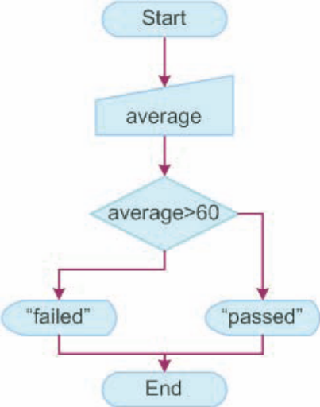
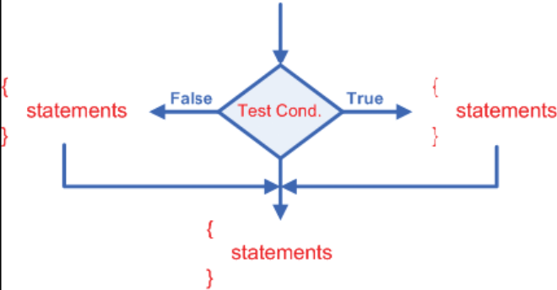

Exercise: Write a program that decides if a number is odd or even.
Input: An integer.
Output: "Odd" or "Even".
Hint: Even numbers are divisible by 2. That is to say when an even number is divided by 2, the remainder is 0. Use modulus operator (%) to obtain the remainder.

CONCLUSION:

HOMEWORK: Write a program that checks if an entered character is between 'a' and 'z' or 'A' and 'Z'. Namely check if it is a letter or not.
Input: One character.
Output: "IT IS A LETTER" or "IT IS NOT A LETTER".

Teacher Director

